School Of Mechanical & Manufacturing Engineering, NUST

Department of Mechanical Engineering

CS-114 - Fundamental of Programing

Lab Manual # 06

**Course Instructor:** Dr Khwaja Fahad Iqbal

**Lab Instructor:** Muhammad Affan

**Student Name: ZORAIZ ABBAS**

**CMS ID: 454752**

**DATE:**

**23 NOV 2023**

Fundamental of Programing

**LAB TASK**

**TASK 1:**

Generate the Fibonacci sequence using nested loops.

**Code:**

#include<iostream>

using namespace std;

int main(){

int x=0,y=1,end,oddsum=0,evensum=0,a=1;

cout<<"Enter the number of terms: "<<endl;

cin>>end;

while(a<end-1){

while(a%2!=0){

cout<<x<<endl;

x=evensum+x;

oddsum=x;

a++;

x++;

}

while(a%2==0){

cout<<y<<endl;

y=oddsum+y;

evensum=y;

a++;

y++;

}

}

return 0;

}

**Result:**

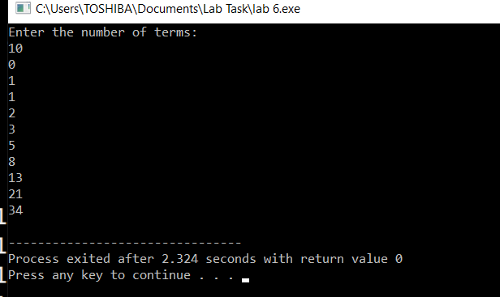

**Task 2:**

Create Floyd’s triangle with nested loops.

**Code:**

#include<iostream>

using namespace std;

int main(){

int rows,num=0;

cout<<"enter the number of rows for floyds triangle: ";

cin>>rows;

for(int i=1;i<=rows;i++){

for(int j=1;j<=i;j++){

cout<<" "<<num;

num++;

}

cout<<endl;

}

return 0;

}

**Result:**

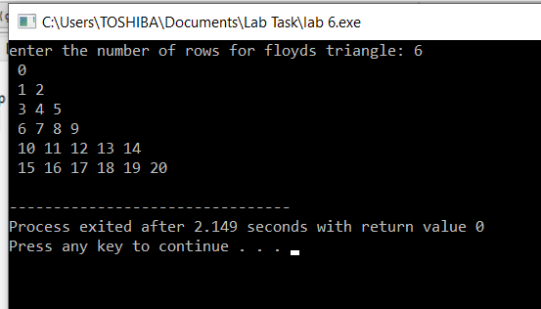

**Home task**

**Task 1:**

Write a program using break or continue statement that only adds prime numbers from 1 to 50 and display the sum on screen.

**Code:**

#include<iostream>

using namespace std;

int main(){

int sum = 0,fop;

for (int i = 2; i <= 50; ++i) {

fop=1;

for (int j = 2; j <= i / 2; ++j) {

if (i % j == 0) {

fop=0;

break;

}

}

if (fop==0) {

continue;

}

sum += i;

}

cout << "Sum of prime numbers from 1 to 50: " << sum <<endl;

return 0;

}

**Result:**

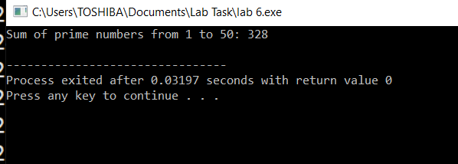

**Task 2:**

Write a program in C++ to create the following pattern.

1

1 2

1 2 3

1 2 3 4

1 2 3 4 5

**Code:**

#include<iostream>

using namespace std ;

int main(){

int rows;

cout<<"Enter the number of rows for triangle "<<endl;

cin>>rows;

for(int i=1;i<=rows;i++){

for(int j=1;j<=i;j++){

cout<<j;

}

cout<<endl;

}

return 0;

}

**Result:**

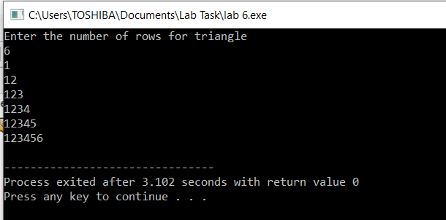

**Task 3:**

Write a C++ program to print:

1

2 2

4 4 4 4

6 6 6 6 6 6

**Code:**

#include<iostream>

using namespace std;

int main(){

int num=2;

cout<<"the required triangle is : "<<endl;

cout<<"1"<<endl;

for(int i=1;i<=3;i++){

for(int j=0;j<=i*2-1;j++){

cout<<num;

}

num+=2;

cout<<endl;

}

return 0;

}

**Result**:

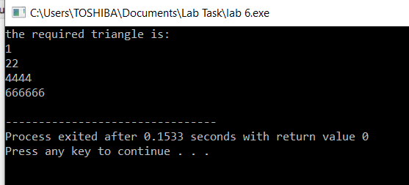

**The End**